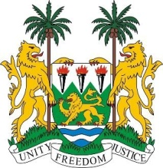
SIERRA LEONE

26th session of the UPR

UGANDA

STATEMENT BY SIERRA LEONE

3 November 2016

Mr President,

Sierra Leone extends a warm welcome to the Ugandan delegation and thanks them for their presentation today.

It is notable that in 2014, Uganda established a National Action Plan for Human Rights and has passed an impressive number of laws relating to human rights. My delegation considers it laudable that the Ugandan Human Rights Commission has enjoyed an “A” status since 2009, despite limitations in funding.

My delegation applauds the government’s 2015 launching of the Ugandan Women Entrepreneurship Programme which is part of their efforts to further empower women economically. Equally, we note that the Marriage and Divorce Bill is currently under review to bring it in line with international standards.

Sierra Leone has the following recommendations:

- Ratify and accede to the ICPPED, the CRPD and remove reservations to the CAT and the ICRMW.
- Submit its overdue reports to the relevant treaty bodies.
- Thoroughly investigate attacks on persons living with albinism, and ensure that perpetrators of violations committed against them are brought to justice.
- Put in place strategies and implement the action plan to more effectively combat child, early and forced marriage.

To conclude, Sierra Leone wishes Uganda every success is completing this UPR session.

Thank you, Mr President.

